
SCHOOL OF COMPUTING AND ENGINEERING SCIENCES (SCES)
BACHELOR OF SCIENCE IN ELECTRICAL AND ELECTRONIC ENGINEERING
VISION AND ROBOTICS LAB 2
Image transformations and filtering
By
Edward Aribu – 142092

Introduction

RGB color model
The RGB (red, green, blue) color model uses additive color mixing, where every color can be made by combining primary colors (red, green, blue) with the appropriate intensity. The RGB color model is used by screens, and consequently used in image processing.
Robotic perception is heavily reliant on the ability to interpret environmental data. However, robots perceive the world through discrete digital bits or data unlike human vision which processes visual stimuli continuously. A digital image is a mathematically defined as a function f(x,y), where spatial coordinates (x,y) are sampled on a grid to produce pixels[1].
To reduce computational complexity for real-time robotics, RGB images are often converted to a single channel grayscale representation using a luminance-weighted sum(I = 0.299R + 0.587G + 0.114B)[2].

Geometric Transformations (Rigid body kinematics)
The flipping as seen in figure 2 is a geometric transformation. In robotics the manipulation of an image frame is mathematically analogous to the motion of a rigid body. The position and orientation of a body are described using transformation matrices[2].
Mathematically, if an image is matrix A of size M*N, a horizontal flip corresponds to a reflection transformation mapping a pixel at (i,j) to A(i,N-j+1). This concept pf coordinate frame manipulation is quite important in robotic kinematics

Gamma correction and linearity
Most digital cameras are stored in sRGB space which applies a nonlinear tone mapping to the raw light data. However, mathematical operations often assume a linear relationship between pixel value and light intensity[3]. The relationship between the stored pixel value and the physical light intensity is approximated by the power law L=V^y (where y is gamma)[4].
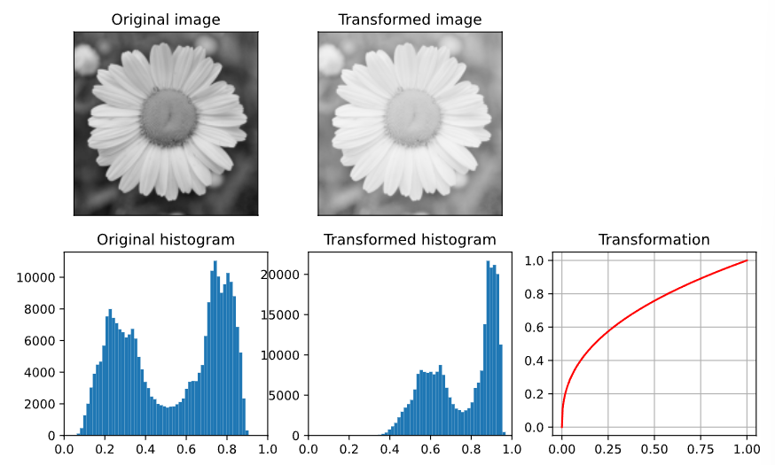
Figure 3. Gamma correction by 0.4[5]

Histogram equalization
It is a technique used to enhance contrast by redistributing pixel intensities. It employs a cumulative Distribution Function (CDF) to flatten or smoothen the image histogram, ensuring the pixel intensities span the full dynamic range
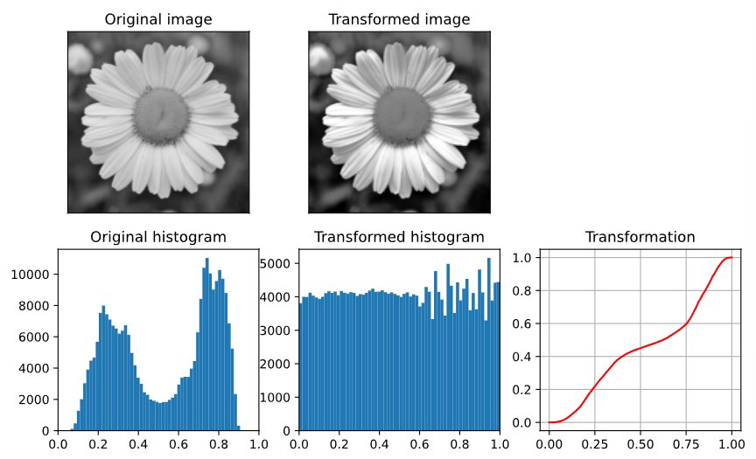
Figure 2. Histogram equalization[5]
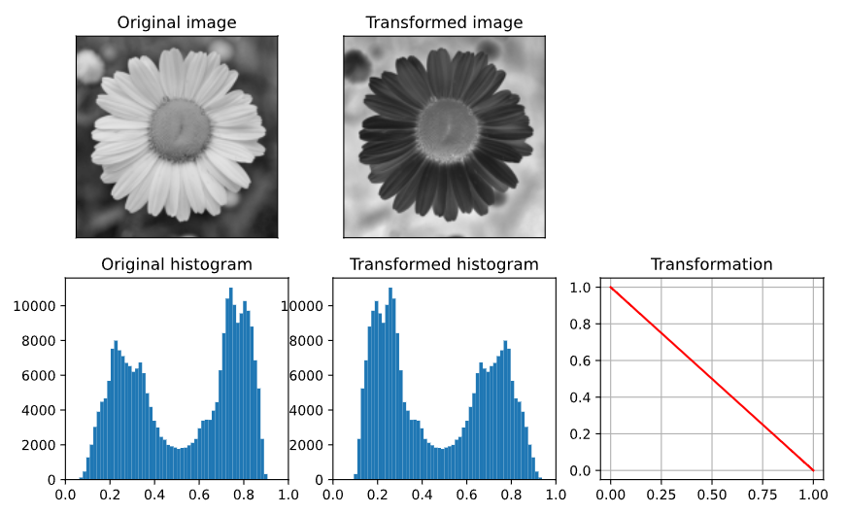
Figure 1. Negative image from histogram transformation[5]

Objectives
- To explore and test different filters on robotic vision.
- To write code that tinkers with an image in different ways.
- To grasp different fundamentals of robotic vision processing.

Procedure
- Using matlab or python, write code that illustrates different image transformations and filters
- Follow instructions as given in classes by the lecturer.
- Generate a lab report based on the lab and illustrate using screenshots

Results

img = imread("C:\Users\admin\Pictures\wallpapers\photo_2023-04-21_14-52-31.jpg");
gray = rgb2gray(img);
imshowpair(gray, img, "montage");
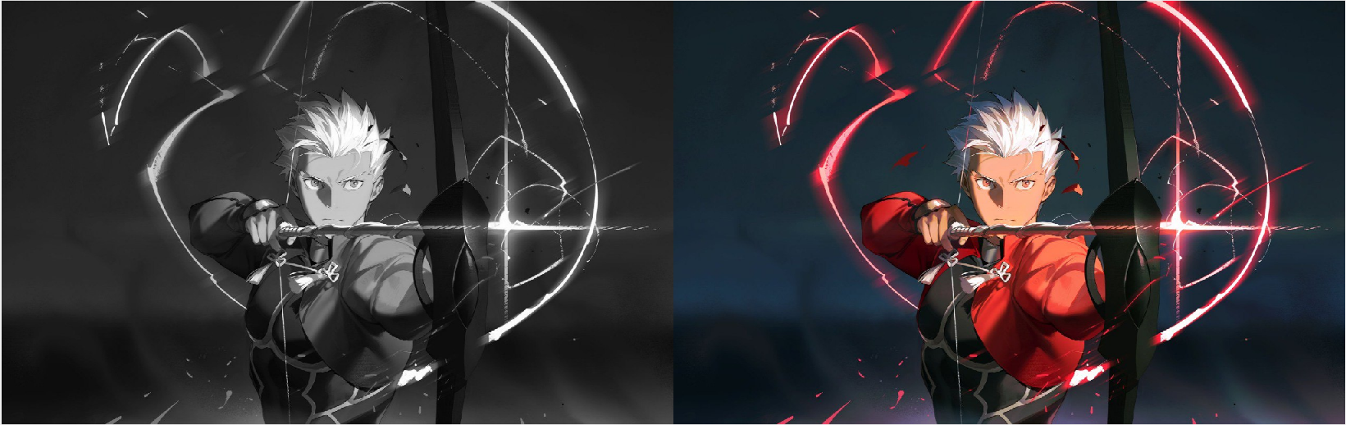
Figure 1. left- grayscale image. right- original RGB image
image2 = imadd(gray, 20);
flipimg = fliplr(gray);
imshowpair(flipimg, image2, "montage");

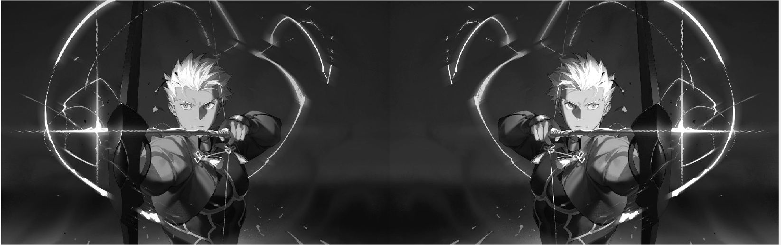
Figure 2. left- flipped grayscale image. right- Automatic contrast stretching.
gamma = 1.5; % < 1 brightens, > 1 darkens
imggamma = imadjust(gray, [], [], gamma);
histogramImg = histeq(gray);
imshowpair(histogramImg,imggamma,"montage");

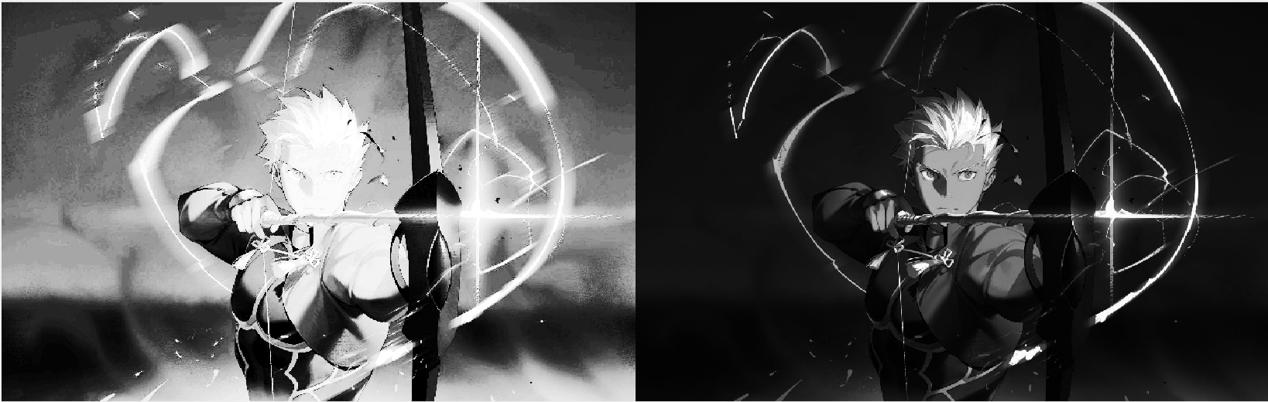
Figure 3. left- histogram equalised image. right- gamma corrected image

Discussion
The results generated replicated the theory and provided suitable contrast between the different MATLAB code functions and transformations as depicted by the images.
The grayscale filter made the image turn into shades of white and black.
The flipping transformation along the X-axis worked as expected
The automatic contrast stretching was not very visible with this specific image so using a different image in future would highlight this function better
The histogram equalized image changed the brightness of the pixels significantly towards lighter shades while the gamma correction of 1.5 significantly darkened the dark tones leaving only some highlights of white on the image.

Conclusion
The main aims of the lab experiment were successfully achieved. This was proven by the exploration of different types of vision processing filters being applied on the image. The MATLAB code were successfully written and fundamentals of the experiment were effectively grasped in accordance with the set objectives

References
[1] ‘2 A Simple Vision System – Foundations of Computer Vision’. Accessed: Jan. 15, 2026. [Online]. Available: https://visionbook.mit.edu/simplesystem.html
[2] R. N. Jazar, Theory of Applied Robotics: Kinematics, Dynamics, and Control (2nd Edition). Boston, MA: Springer US, 2010. doi: 10.1007/978-1-4419-1750-8.
[3] ‘8 Color – Foundations of Computer Vision’. Accessed: Jan. 15, 2026. [Online]. Available: https://visionbook.mit.edu/color.html
[4] ‘Digital Image Processing’. Accessed: Jan. 15, 2026. [Online]. Available: https://classroom.google.com/c/NzgxMTYwNTYyMjgy/m/ODM4MjM4MDY1MjY0/details
[5] ‘Histogram — Basics of Image Processing’. Accessed: Jan. 15, 2026. [Online]. Available: https://vincmazet.github.io/bip/digital-images/histogram.html

